INTRODUCTION TO MOBILE DEVELEPMENT

**PROJECT PART A:** SkytrainApp Analysis and Review

**Simon Li**

Instructor, CSIS 3175-002

**Group 5**

Brandon Frison 300243731

Matthew Lai 300228124

Alan Chang-Il Lee 300247998

Andrew Turner 300240311

**INTRODUCTION AND REVIEW STRUCTURE**

Our group, Group 5, has chosen to review 4 apps from the Google Play store that deal with the Skytrain system. These 4 apps are: Vancouver Translink Live, Vancouver Skytrain, Transit: Real-time Transport, and TransitDB Vancouver. For each app review, we focused on five separate areas, each weighted differently for a total score out of 100. The 5 areas are:

* **Usability:** How intuitive or easy the app is to use. Weighted out of **35.**
* **Aesthetics:** How visually appealing the app is. Weighted out of **20.**
* **Responsiveness:** How fast and smoothly the app behaves. Weighted out of **20.**
* **Support:** How often the app receives updates as well as how tech support is available. Weighted out of **15.**
* **Additional Features:** Any extra features the app has. Weighted out of **10.**

It is important to note that the scope of this report is of how the app handles the Vancouver Skytrain system, and so the reviews’ focus is on that aspect. While an app may support other systems, these are weighted less (in the Additional Features section).

**REVIEW No. 1**

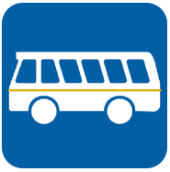

**APP NAME:** Vancouver TransLink Live

**VERSION:** 1.2.20

**DEVELOPER:** Jamie O’Toole

**LAST UPDATED:** January 15, 2017

**DOWNLOADS:** 1,000 - 5000

**PLAY STORE RATING:**  4.2 Stars (12 reviews)

**Vancouver TransLink Live** is a location based transit guide for the Metro Vancouver area. It displays nearby stops, allows users receive a trip plan to popular destination, receive schedule for selected bus stops to name a few of the main features. It allows for users to quickly navigate to the next bus coming to nearby/favourite stops and find the best route to reach their destination.

**Usability**

The app is simple to use and navigate it contains a simplistic interface that allows users to quickly find the information on bus schedules and routes with relative ease and speed.

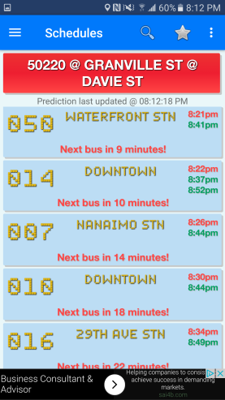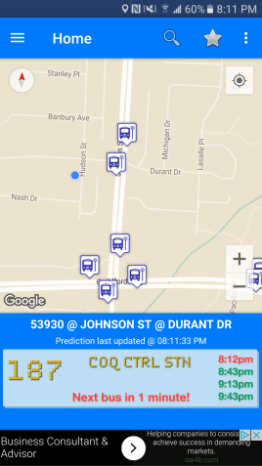The app requires that GPS be on to make full use of the features when GPS is turned the app opens to a map of the local area with nearby bus stops and station marked. This feature allows users to quickly check the schedule of the stops without having to search by Id or name. But if you want to look at a stop that is out of you current range you will have to search for it since the app only displays nearby stops and stops flagged as favourites when it first opens.

When searching the app allows users to search for either route or stop when a route is selected all stops along that route are marked on the map allowing users to find the nearest stop to their location. When stop is selected the app displays the arrival time of the next few buses/trains for all the buses/trains that use the selected stop.

The app does not allow for future planning since it is limited to only buses and trains coming in the next little while it do not allow users to future plan. The app also creates confusion when selecting a stop after selecting a particular route as it then takes you to from displaying the routes to displaying the stop which if you are looking at a specialty bus that has no upcoming times if you don’t look carefully it could be easy to mistake one bus for another.

The app also struggles with the sky trains routes as it will incorporate them into trip plans and display the routes/stations when searched for but when clicked on bring the user to a page that does not give any of the upcoming times of the trains.

**Responsiveness**

Overall the app has a quick response time there is no noticeable load time even when finding and displaying your current location. The search function overall is quite fast with the only delay being broad searches such as searching for stops with the letter “A”. When calculating trip plan the app has almost no delay and loads the plan almost immediately overall the speed of the app is excellent.

**Aesthetics**

The app is simplistic and map based it contains gentle colour tones that make it easy on the eyes the functions are laid out in an orderly fashion. Making them easy to find and adding to the overall style of the app. The app makes use of the old saying “less is more” as the developer kept the screen as simple as possible only initially displaying what is needed. This is especially noticed with the stops as the app only displays the nearby stops on start up it keeps the screen from becoming cluttered and overwhelming when it is first opened.

**Support**

The app receives good support from the developer as of now even though it is a relatively small transit app. Looking through the comments and some complaints of the app of the play store when a complaint was made the developer would often address the complaint inquiring what wasn’t working or the user did not like so that he may further improve upon his app.

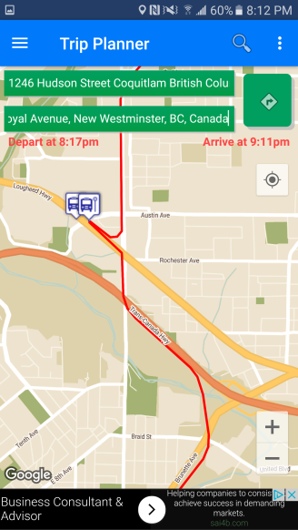**Additional Features**

Besides the traditional expect functions of a transit app such as trip planner, display of schedules and local routes that developer add a few interesting features to the app. One such feature is bus prediction this feature automatically runs on start up this features tells the user via banner at the bottom of the screen when the next bus for the nearest favourite stop is coming. If no favourite’s stops are within range the app automatically selects the nearest stop and displays the next bus for that stop. Then the prediction will update whenever the user selects another stop making it easy for the user to check when the next bus is coming by. The app will also mark and unmark stops on the map based on user selection for instance when selecting a route is will display all stops along that route but once the route is deselected the map will hide all of the routes again keeping the map nice and clean.

**Final Conclusions**

The app for the most part does what is expected of it quite well it plans trips accurately and displays the routes and schedule in a neat and easy to read fashion. But I feel the app could be improved upon in the Skytrain section as the info isn’t always displayed. Furthermore the even though you can look at the info offline the app is map designed so it loses most of its functionality when offline. In conclusion the app does do what is said it would do but leaves room for improvements.

|  |  |
| --- | --- |
| **FINAL SCORES** |  |
| Usability | **28 / 35** |
| Aesthetics | **18 / 20** |
| Responsiveness | **15 / 20** |
| Support | **13 / 15** |
| Additional Features | **9 / 10** |
| **TOTAL : 83 / 100** | |

**REVIEW No. 2**

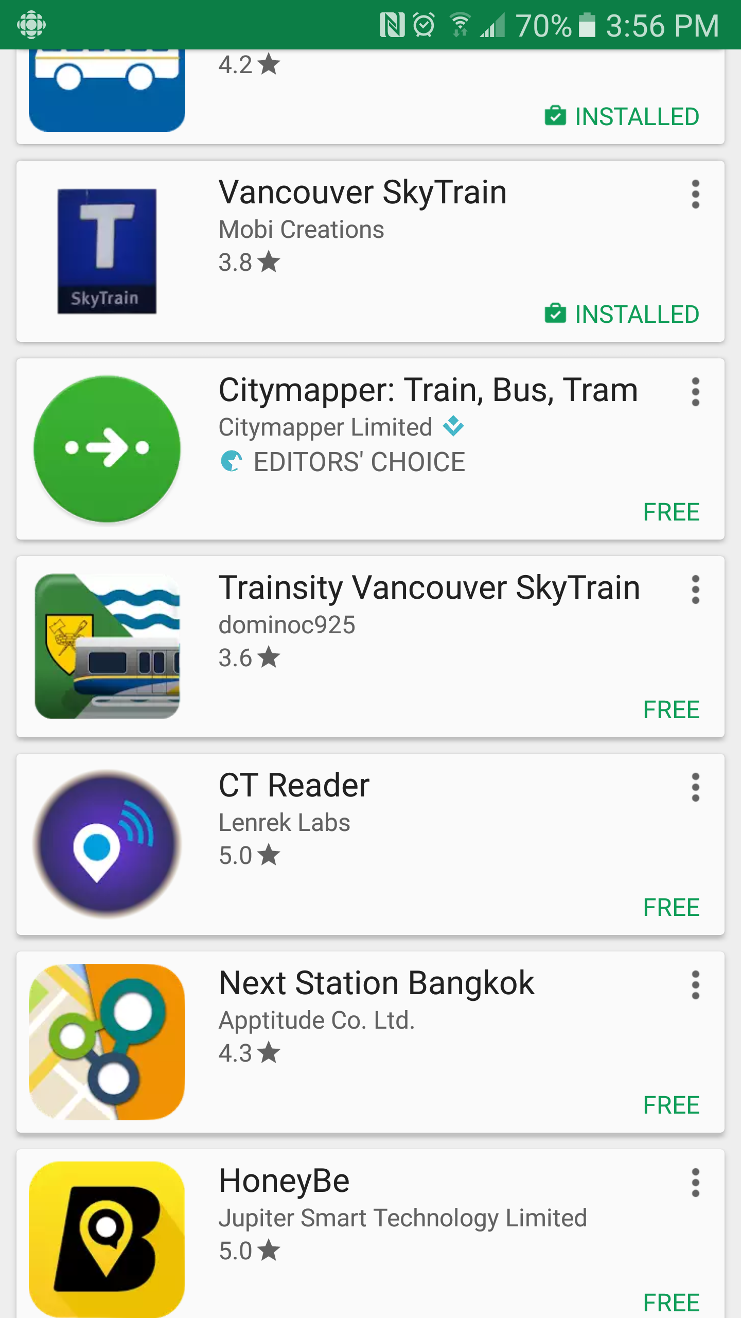**APP NAME:** Vancouver Skytrain

**VERSION:** 1.01

**DEVELOPER:** Mobi Creations

**LAST UPDATED:** January 25, 2012

**DOWNLOADS:** 10000

**PLAY STORE RATING:** 3.8 Stars (39 reviews)

**Vancouver SkyTrain App** provides shortest path (number of stations) and its trip time, fare (regular and special)

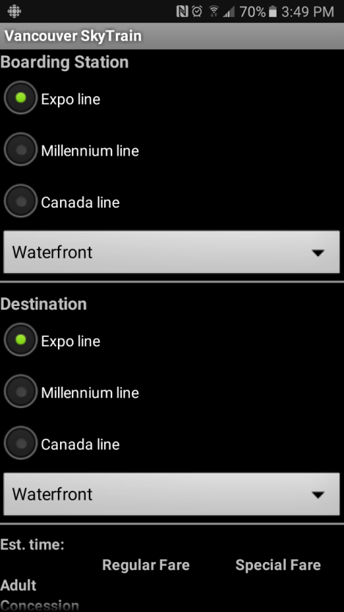**Usability**

Vancouver SkyTrain App has very clear structure to understand how to use it. User just needs to select boarding station and destination station. The app automatically shows the information without click any button.

However, when the user select one of stations, the user has to select SkyTrain line (Expo, Millennium, Canada) first, that means the user needs to know which station belongs to a certain line. But it doesn’t support search station feature so that users can feel difficulties to select their target stations.

It’s quite light and doesn’t need network or GPS signal. Therefore, users having no enough data or battery also can use it conveniently. Station path result doesn’t mark the transit point or line changing information. User might pass the transit point and get lost. It should have been shown at least by different color of station name

**Responsiveness**

This app provides users with only very simple informationand there is no additional information requiring network or GPS signal. Therefore, it’s fast and couldn’t feel any processing time to show the results.

**Aesthetics**

It has just black background and white characters. There are radio buttons to select SkyTrain line, dropdown list to select station which is string type information.

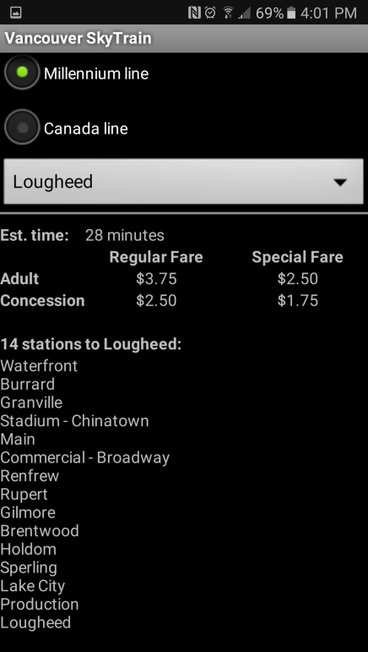

It doesn’t use any color or icons which is matching with TransLink, SkyTrain, or its line. For example, TransLink mostly use blue and yellow color, and each line has its unique color (Millennium: yellow, Expo: blue, Canada: sky-blue). This makes user more difficult to search station and track their journey.

It managed to be called a graphical user interface and I couldn’t find any efforts to make it looks better.

**Support**

This app is not updated recently (the latest update is in 2012) and fare information is out of date (1 zone shows 2.5 which is actually 2.75, 2 zone as 3.75 which is 4, and 3 zone as 5 which is 5.5). This app was updated just once after initial release. It seems like being neglected now.

Obviously, Evergreen line does not exist

**Additional Features**

Estimation time could be mentioned as an additional feature.

**Final Conclusions**

Vancouver SkyTrain app is good for travellers who just want to know about SkyTrain route without network or data consumption. It has light and straightforward user interface so that it’s easy to use without any adopting period. – This point could work for old generation or people who can’t handle smart devices well. However, it’s not decent to figure out user’s journey because it doesn’t show map (including SkyTrain route map) and transit point neither. Even worse, it doesn’t provide any graphical or colored clue to assume which station belongs to a certain line. Due to the lack of update, its fare information is not correct and there is no Evergreen line station (Even though the fact that official TransLink web page also still has no information on Evergreen line).

|  |  |
| --- | --- |
| **FINAL SCORES** |  |
| Usability | **25 / 35** |
| Aesthetics | **3 / 20** |
| Responsiveness | **20 / 20** |
| Support | **3 / 15** |
| Additional Features | **3 / 10** |
| **TOTAL : 54 / 100** | |

**REVIEW No. 3**

**APP NAME:**  Transit: Real-Time Transport

**VERSION:** 4.1.3

**DEVELOPER:** Transit App, Inc

**LAST UPDATED:** January 12, 2017

**DOWNLOADS:** 1,000,000+

**PLAY STORE RATING:** 4.2 Stars (32,725 Reviews)

**Transit: Real-Time Transport**, or just **Transit**, is an immensely popular trip navigation app whose main features includes real-time tracking of transit vehicles, support for the transit systems of over 125 cities, and one-click planning of trips.

**Usability**

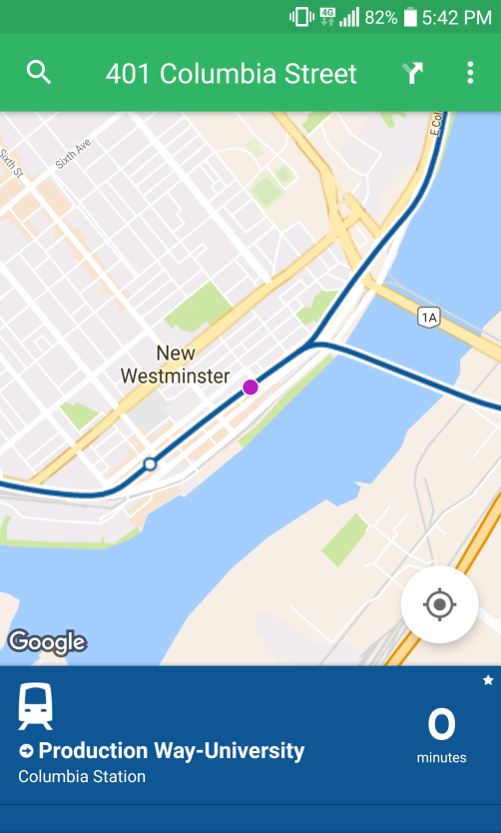As its popularity would suggest, the Transit app is quite easy to use, with many intuitive features to help new users get started.

Like many modern navigation apps, Transit uses the popular Google Maps API to display locations. Due to the prevalence of Google Maps, most users are familiar with its look and feel, allowing even first time users of the app to quickly get their bearings.

The one complaint that can be raised with this however is that on the overlay the app uses to display bus and train lines, the symbol for train stations is very small and does not scale with the map’s zoom level; which could cause confusion for newcomers to the Vancouver area who may not know the actual locations of the stations. This issue with the small and potentially unclear icons is an issue that is common throughout the app.

Perhaps one of the strongest points of the app is its trip planning ability. Assuming that the phone’s location tracking option is enabled, the user simply needs to select the line they wish to travel on, and then select the station they wish to get off at. The app will then calculate the schedule and notify the user when to get on/off the train. The map will also then update to track the user’s progress on the trip, with a trip itinerary complete with estimated arrival times for each station along the way displayed under the map.

The trip planning does have several weaknesses. Selecting the direction of the line at first was confusing, as each train line is represented as one button; for example the Expo line, which has trains going to Waterfront and Production-Way is only shown as the Expo Line, with the Waterfront train being the default selection. In order to the change direction, the user must swipe the button. This can be especially confusing as there is no prompt to do so, and both directions share the same colour.

The most glaring issue however becomes apparent when planning a trip that involves a line with multiple trains on the same track; i.e. the King George and Production-Way trains on the Expo line. Assuming the user was at a station such as New Westminster or Columbia travelling east-bound, there was no apparent way to select which train to take; the app making the decision for the user. To clarify, at one point the user could only select the westbound Waterfront train or the eastbound King George train; even though they may want to take the Production-Way train.

A while later, at app on its own (with no obvious input from the user) changed the eastbound selection to Production-Way. Now the opposite was the case, with the user being unable to plan a trip to Surrey.

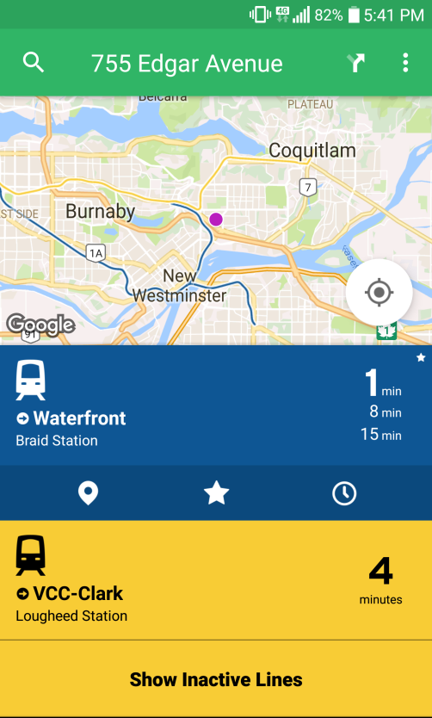**Aesthetics**

The app’s design is one of its strong points; the app overall having a very clean and modern look. Its selection of colours for the controls is bright and contrasts well with the white background of the app and of Google Maps.

The font-type used for the text is a sans-serif type that renders very well on the screen; this combined with the enlarged font-size for line names/numbers results in a readable UI that is clear and easy to understand.

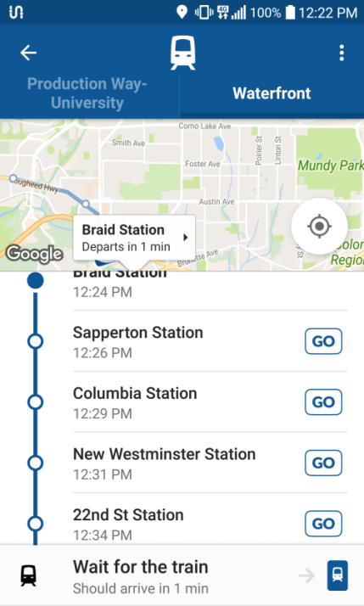The main complaint with the appearance of the app is that the screen can very quickly become cluttered with different information, notifications, and menus which can make navigation a nightmare. This is most readily apparent when a trip has already been planned and is in progress, and the user looks up the schedule for another line. The screen will then become filled up with the app’s header, the map display, the schedule view, and finally the plan notification at the bottom.

**Responsiveness**

For the most operations, Transit runs smoothly and quickly; giving the desired output in a timely manner. However, there are some issues that decrease the app’s responsiveness. The first is the fact that it relies on the phone’s internal GPS feature in order to make full use of the app’s trip location tracking feature. Needless to say then, if said GPS is interrupted, then so will the trip tracking. This is less a fault with the app’s design than it is an inherent issue with any real-time data, and so this issue is relatively minor.

The second issues it that because much of the displayed data, such as available lines, are relative to where the current location is set, when the user moves the location cursor around on the map, the app controls have a tendency to “jump” or even disappear. This is most readily apparent in the case of where if the user has a menu open and is scroll through a list, they may accidently brush up against the map display; causing the location to change and the menu they had open to close.

Finally, the third and probably most important issue is that the app’s description of being ‘real-time’ is misleading, as the location tracking for the Skytrain is based on the train schedule, and not on the current location of the vehicle itself. This can be clearly seen when an in-progress trip is being tracked; the phone’s location is shown to be in a different location than the train icon.

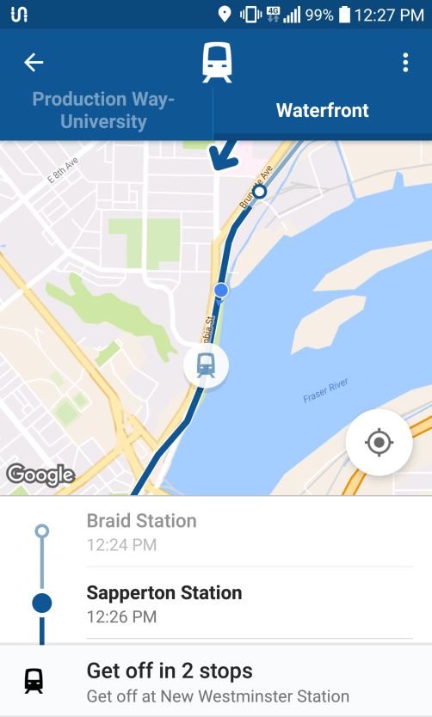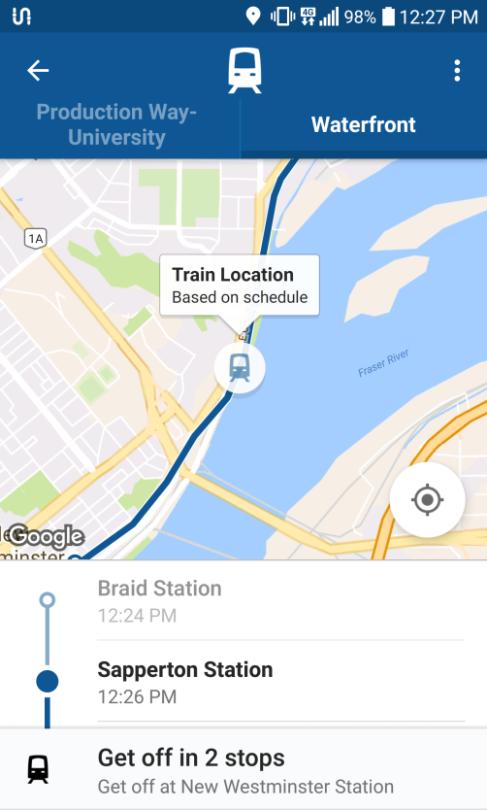

It is important however to note that it the app’s primary area is bus lines, and so the real-time tracking feature described maybe more relevant to buses than to trains. However, because the focus of this review is strictly on the Skytrain system, how well the app works with buses is not considered directly with in the score.

**Support**

As one of the most popular apps, it should be no surprise that finding support for Transit is very easy. The developers maintain a semi-active blog on their site as well as a Twitter account which posts updates once or twice a month. Despite this, they are quite active in answering questions, with the Twitter account responding to users who have technical issues with the app. The same applies to the Google Play store, where the developers on occasion respond to user reviews and comments that highlight issues in an attempt to improve the app.

The only complaint that can be raised is that a full changelog of the app could not be found anywhere on their site or their Google Play page. This is mildly annoying, as the descriptions of their updates can be very vague and unhelpful to users who want a more technical explanation.

**Additional Features**

Although the focus of this review is on how well the app handles the Skytrain system, Transit does have other features that branch out of that scope. The app’s region is not limited to only Translink; it supports (from their description) over 125 cities in both North America and Europe, such as Edmonton’s ETS or Toronto’s TTC.

The same trip planning and real-time tracking features that Transit has for the Skytrain is also afforded to bus lines. In fact, it is probable that the app was originally built with buses in mind as the primary service; with buses being more numerous than trains. Although it was not tested as thoroughly, the real-time tracking for buses appeared to be more accurate than for the Skytrain; with the location at least not being estimated from the schedule.

**Final Conclusions**

Overall, despite its flaws the Transit app provides a very solid experience, and ultimately fulfils its goal of planning and managing trips easily. Although its scores suffered in some categories due to the Skytrain focus of this review, it is the opinion of the reviewer that this app and its features would definitely be more than adequate for everyday use.

|  |  |
| --- | --- |
| **FINAL SCORES** |  |
| Usability | **28 / 35** |
| Aesthetics | **18 / 20** |
| Responsiveness | **10 / 20** |
| Support | **14 / 15** |
| Additional Features | **10 / 10** |
| **TOTAL : 80 / 100** | |

**REVIEW No. 4**

**APP NAME:**  TransitDB Vancouver

**VERSION:** 2.1.3.0

**DEVELOPER:** Carson Lam

**LAST UPDATED:** January 3, 2017

**DOWNLOADS:** 50,000 - 100,000

**PLAY STORE RATING:** 4.6 Stars (708 reviews)

**Usability**

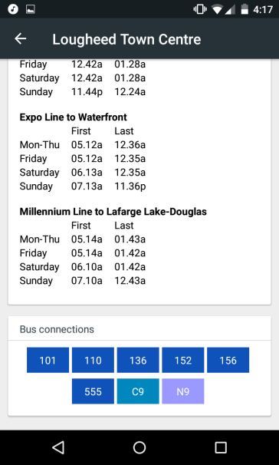The main sky train related features in TransitDB were easy to find and easy to use. There are additional labels on many of the sky train stations to indicate if it has transfer options to different routes. Every text field you wish to enter offers a help tip to indicate what you are supposed to type in that area. The app gives the next 6 trains from the current time but they are based on schedule and not real time updated.

First and last departures of the day are also displayed for each station. At the bottom of each station bus connections to other stations are displayed as buttons for the names of each bus. If you click on them they expand to a new activity and show similar information to the sky trains such as the next 6 buses arriving and the frequency of buses on particular days of the week.

The app visibly shows the fare zone of each station so you can determine how much money to load or what ticket to buy before departing on your trip. If this app included a trip planner it would have been helpful to display these total fares after a starting point and destination were selected. For use of strollers and wheelchairs the app shows if each station has features including wheelchair access, elevators, Wi-Fi, bike accessibility and more.

**Aesthetics**

The app does not include a live map of all stations but is instead a text based design what it lacks in visually pleasing aesthetics it gains in ease of use and simplicity. The colour scheme is very bland with very few colours only used as backgrounds on title labels and sky train diagrams.

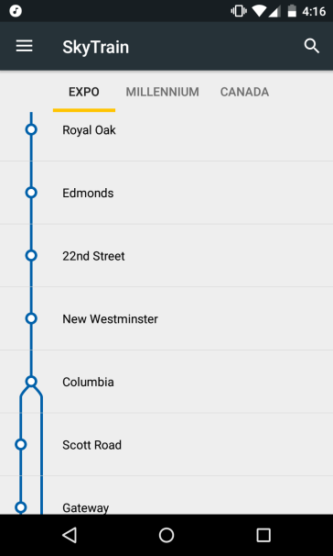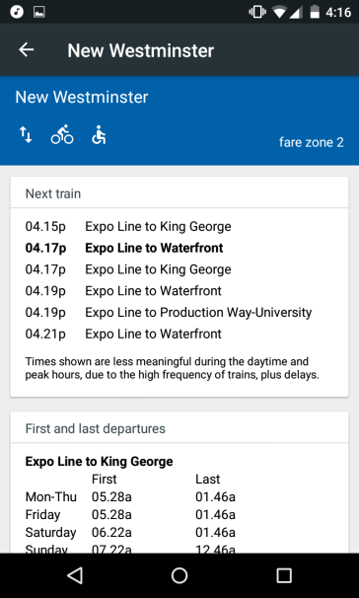

While a black/grey/white colour palette isn’t for everyone I quite enjoyed the easy on the eyes feel of the app. I found the font size to be readable yet spacious and flowed well with the design of the app.

**Responsiveness**

Since TransitDB is text based and can be used offline the response time of all its options is very speedy and any lack of response time I condemn to the age and power of my phone not the app itself. The search function is near instantaneous at collecting large pools of data from its storage. The app has never crashed in my short time using it and I have seen in the changelogs that reported crashes caused by bugs are fixed within a very short period.

**Support**

App was most recently January 3rd2017, fairly recently and was one of the very first apps to update the new evergreen extension almost immediately after its release on December 2nd 2016 and It also updated the bus routes shortly after December 19th 2016 when they went into effect.

TransitDB includes a changelog which goes almost a full 2 years back from current date. If you find bugs or experience consistent crashes, there is a useful “give feedback” feature to let them know of your inconvenience with just an email and feedback text fields. Another criticism I have of TransitDB is that it does not include a map of all the sky train stations and which line they are on.

**Additional Features**

The app also displays bus routes, Seabus and west coast express. It also features a very useful compass card loading system which can update u-pass and check current balance. The app also presents information about taxi fares and phone numbers to contact a designated taxi. My app has an additional section to show transit fares and which zones.

Some features which are not included in the app that I would like to see are a trip planner as you have to know exactly which route you are taking to use this app effectively and a live map with use of the location setting to determine where you are and where you need to get.

**Final Conclusions**

Overall, I found the app to be extremely effective at a niche usage of finding timings of sky trains and bus arrival times for short term planning. Personally I enjoy this app for its simplistic features and fast run times, however I can see that for long trips or navigation it can be far from ideal. I can also see that the many improvements I suggested would come at a cost to the apps responsiveness and support.

|  |  |
| --- | --- |
| **FINAL SCORES** |  |
| Usability | **30 / 35** |
| Aesthetics | **15 / 20** |
| Responsiveness | **20 / 20** |
| Support | **15 / 15** |
| Additional Features | **6 / 10** |
| **TOTAL : 86 / 100** | |

**FINAL ANALYSIS AND IDEAL APP**

Our ideal app for the Skytrain system of Translink would for it to be on the Google Play store as well as the app store for Apple products. The main focus of the app should be on its core functions and feature a straight-forward user interface to locate information promptly.

It would include two interfaces: a text-based UI which would include a trip planner to show the optimal route between two stations, and a map-based interface with a location feature to show nearby routes. The app would utilize a visually pleasing theme with various personalization preferences. The trip planner should be able to differentiate between different trains which run on the same track and allow the user to select which.

A search function to filter out specific stations or Skytrain lines would be very useful as well as a favourites feature to exclusively display the most frequently used Skytrain stations. Additionally, precise distance tracking and time estimation between stations with accompanying context notifications would be ideal.

Finally, as an additional feature, it would be useful to include the time of various buses which leave the station and to include additional information about each station such as elevator access or ongoing construction.